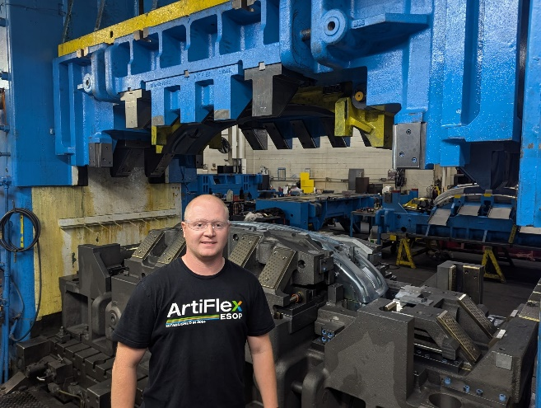
TYLER ARMOCK
Tyler’s Journey: From Coopersville High – MEPP program, to Senior Design Engineer
When Tyler graduated from Coopersville High School in 2014, he had one clear goal: he wanted to turn his love for CAD (Computer-Aided Design) into a real job. Thanks to the Manufacturing Engineering Partnership Program (MEPP), he made it happen—right out of high school.
Back then, Tyler took just about every MEPP class he could: Woods, Metals, Plastics, Engineering, MEPP Prep, and especially CAD. He didn’t stop at one class either—he went all the way through CAD 1, 2, 3, 4, and even Advanced CAD. In his MEPP application, he wrote: “I hope to get a good job right out of high school drawing CAD.”
Fast forward to today, and that’s exactly what he’s doing. Tyler met his career goal!
Tyler got hired at ArtiFlex Manufacturing right after graduation—and he’s still here 11 years later. He took advantage of ArtiFlex’s tuition reimbursement program to earn his Associate’s Degree in Manufacturing Engineering Technology at GRCC – debt free!
So, what’s it like to be in a career that the MEPP program prepares you for?
Tyler says his proudest accomplishment is being able to design complex tools. One of his biggest projects was creating a progressive die that makes more than a million parts every year. “I designed it strong enough to last and keep running,” he says. “And the cool thing is, with every project—big or small—you’re always learning something new. Even after 11 years, I still learn something new all the time.”
When asked what advice he’d give Coopersville students thinking about MEPP, Tyler doesn’t hesitate: “I highly recommend it. The program is especially helpful if you’re not sure about college. There are other paths to success besides a 4-year degree. Most of my learning has actually been on the job.”
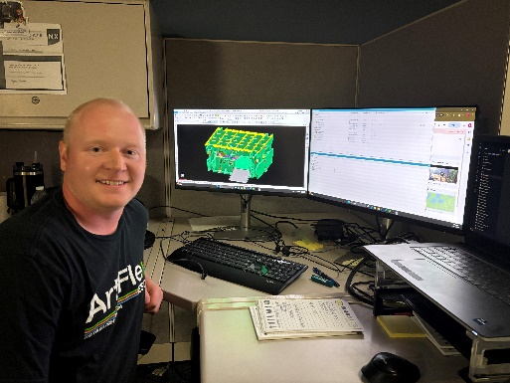
His favorite MEPP memory? The chance to interview with multiple MEPP partner companies. “That experience helped me prepare and do my best,” he says. “I ended up getting my job at ArtiFlex because of it.”
If he could give advice to his high school self, Tyler would remind himself that learning never stops—and that the effort you put in early can shape your entire career.
For Coopersville students thinking about MEPP, Tyler’s journey is proof: you don’t need to have it all figured out to start building a successful future. Sometimes, you just need to take the first step.

- A proud partner of the Coopersville High School MEPP program

